**The Highland Arts Council presents its sixth Art of Soul, a workshop of artistic fun for ages 14 to 103.** Whether you’re an artist, enjoy experimenting with art, or are simply an art enthusiast, Art of Soul has something for you!

Each workshop will offer games and instruction in a specific artistic medium. All materials will be provided for each class. You will go home with at least one project from each workshop. You’ll discover how to capture creative ideas and build on those experiences.

**Art of Soul costs $40 which includes the entire FIVE session experience and most materials!**

If you’ve always wanted to experiment with artistic expression or learn to unblock your flow of creativity, Art of Soul is just what you need. **We promise you a fun-filled experience!**

**Session I:** On Thursday, February 20 from 7 pm – 9 pm, Lynnette Schuepbach will show doodles can become a piece of art. Lynnette is an author, artist and president of Highland Arts Council. She loves encouraging creativity in everyone.

**Session II:** Sarah Walker will share her skills in bookmaking on Thursday, February 27 from 7 pm – 9 pm. Sarah is a professional artist from Highland. She serves on the Highland Arts Council and is pursuing her Masters of Fine Arts degree at SIUE.

**Session III:** On Thursday, March 5 from 7 pm – 9 pm, Peg Bellm, a professional artist, will help you create a hinged box with polymer clay. Peggy Bellm creates one of a kind items using polymer clay and is an award-winning artist at Art in the Park.

**Session IV:** Paulette Todd, artist and teacher, will share her techniques for painting with pastels on Thursday, March 12 from 7 pm – 9 pm. Paulette regularly teaches classes in her business, Kids Art Club.

**Session V:** Printing making is an ancient technique. Christy MacMorran will show how it can be done with modern supplies on Thursday, March 19 from 7 pm – 9 pm. Christy was an award-winning artist at Art in the Park in 2018 and teaches classes in various mediums.

For more information or to register online, go to: **HighlandArtsCouncil.org/art-of-soul/** or call **618-558-0054.**

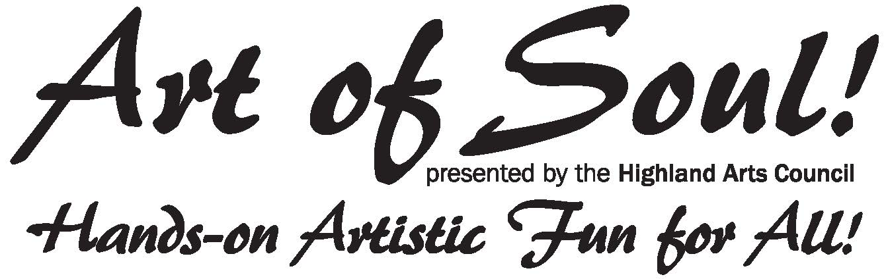

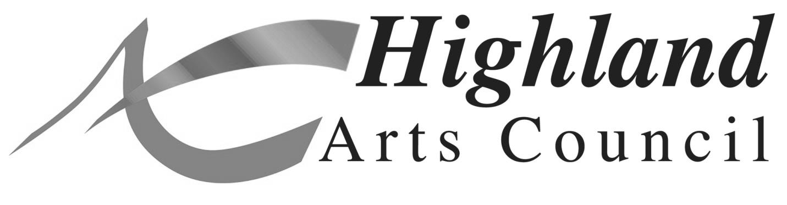

**Session Dates: February 20, 27 and March 5, 12, 19 (Thursdays)**

**Session Time: 7 – 9 pm**

**Session Location: EvUCC, 2520 Poplar Street, Highland, IL**

